**ASSIGNMENT REPORT- 1**

**(*Task : to answer all the given questions from* (SET – A))**

Submitted by

**(Mogalraj Kushal Dath)**

**Registration Number : 12100559**

**Course Name : Advanced Data Structure and Algorithms**

**Course Code : CSE523**

**Section Number : K21ML**

Submitted to

**(Tejinder Thind Sir)**

**School of Computer Science and**

**Engineering**



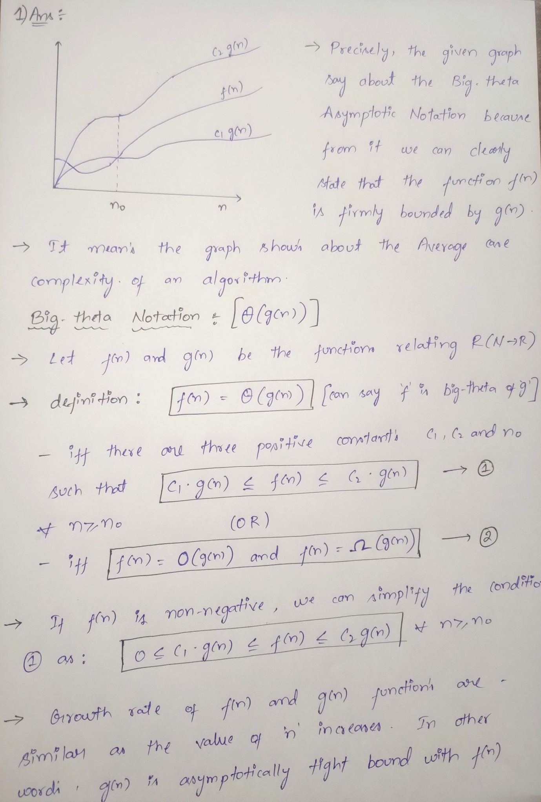

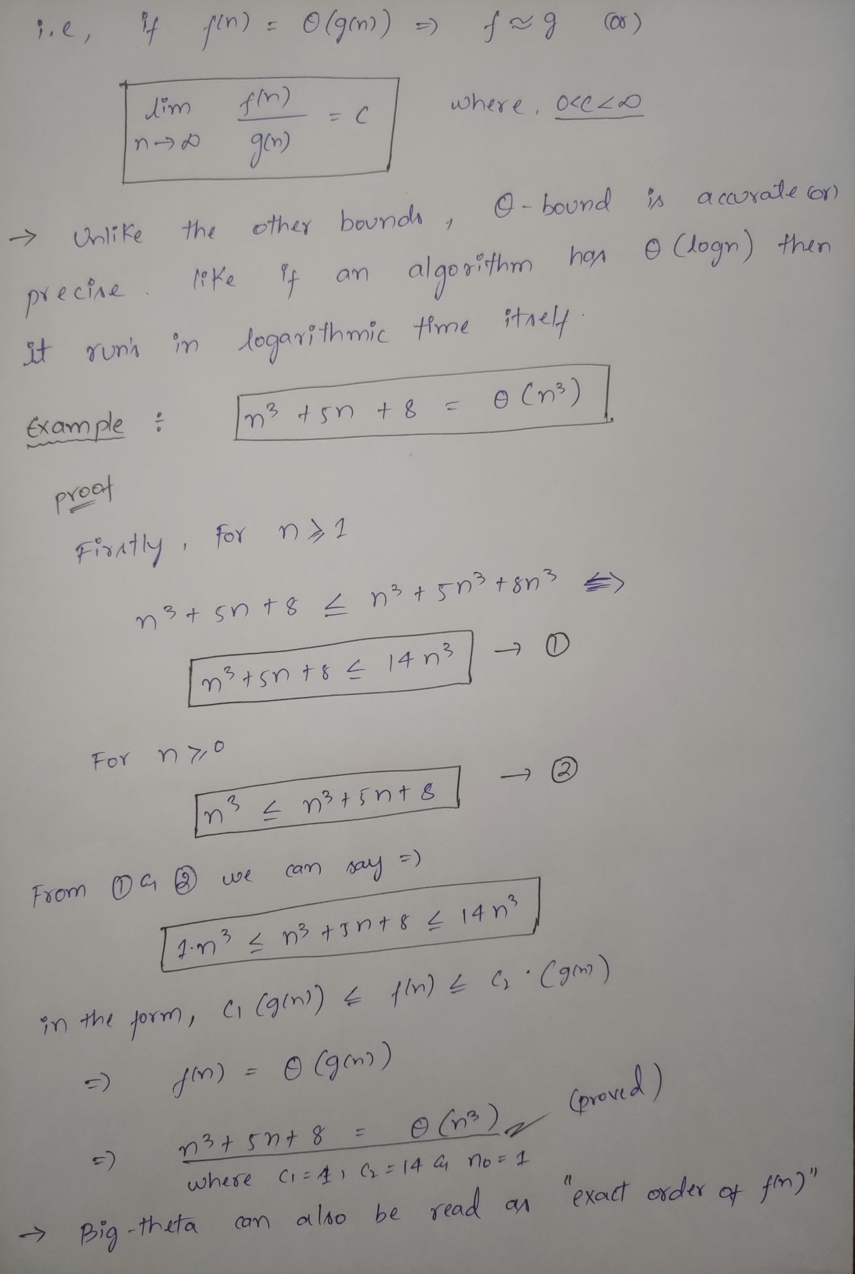

**2) Ans:**

|  |  |  |  |  |  |
| --- | --- | --- | --- | --- | --- |
| **Comparison of Growth Rates** | | | | | |
| **n** |  | **n** |  |  |  |
| 1 | 0 | 0 | 1 | 1 | 2 |
| 2 | 0.693147 | 1.38629 | 4 | 8 | 4 |
| 3 | 1.098612 | 3.29583 | 9 | 27 | 8 |
| 4 | 1.386294 | 5.54517 | 16 | 64 | 16 |
| 5 | 1.609438 | 8.04719 | 25 | 125 | 32 |
| 6 | 1.791759 | 10.7505 | 36 | 216 | 64 |
| 7 | 1.945910 | 13.6213 | 49 | 343 | 128 |
| 8 | 2.079442 | 16.6355 | 64 | 512 | 256 |
| 9 | 2.197225 | 19.7750 | 81 | 729 | 512 |
| 10 | 2.302585 | 23.0258 | 100 | 1000 | 1024 |
| 11 | 2.397895 | 26.3768 | 121 | 1331 | 2048 |
| 12 | 2.484906 | 29.8188 | 144 | 1728 | 4096 |
| 13 | 2.564949 | 33.3443 | 169 | 2197 | 8192 |
| 14 | 2.639057 | 36.9467 | 196 | 2744 | 16384 |
| 15 | 2.708050 | 40.6207 | 225 | 3375 | 32768 |
| 16 | 2.772588 | 44.3614 | 256 | 4096 | 65536 |
| 17 | 2.833213 | 48.1646 | 289 | 4913 | 131072 |
| 18 | 2.890371 | 52.0266 | 324 | 5832 | 262144 |

